**JustCallUz**

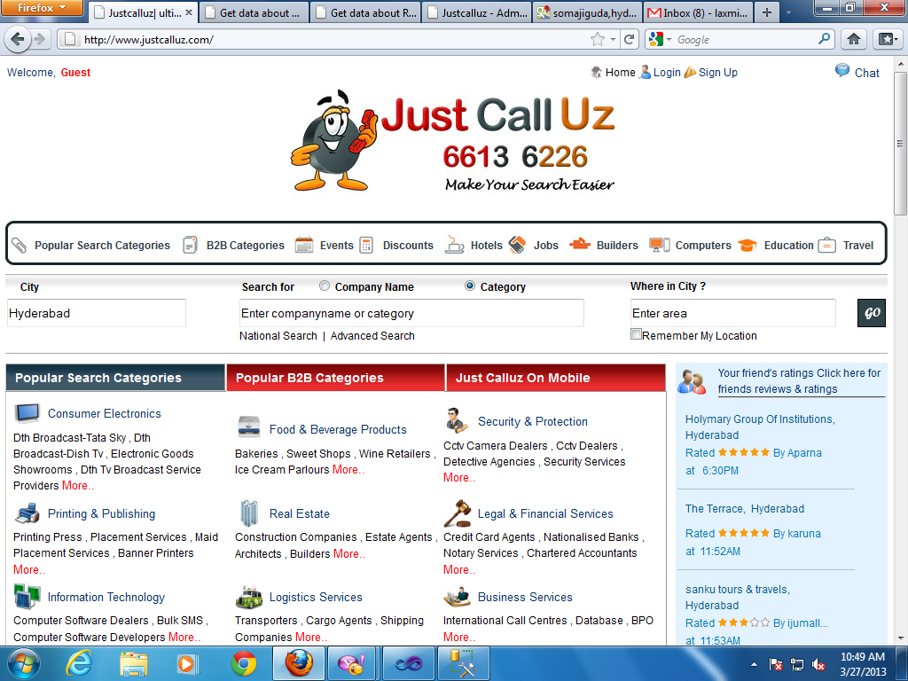

Set the city alignment left

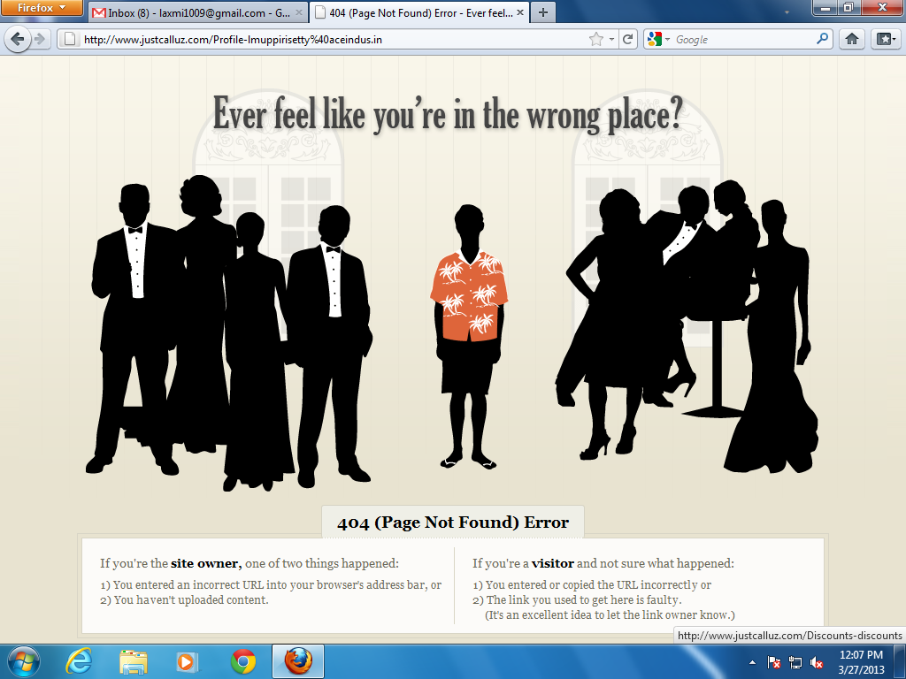

* Got an error when I clicked on “My Profile” and check postings (after login).

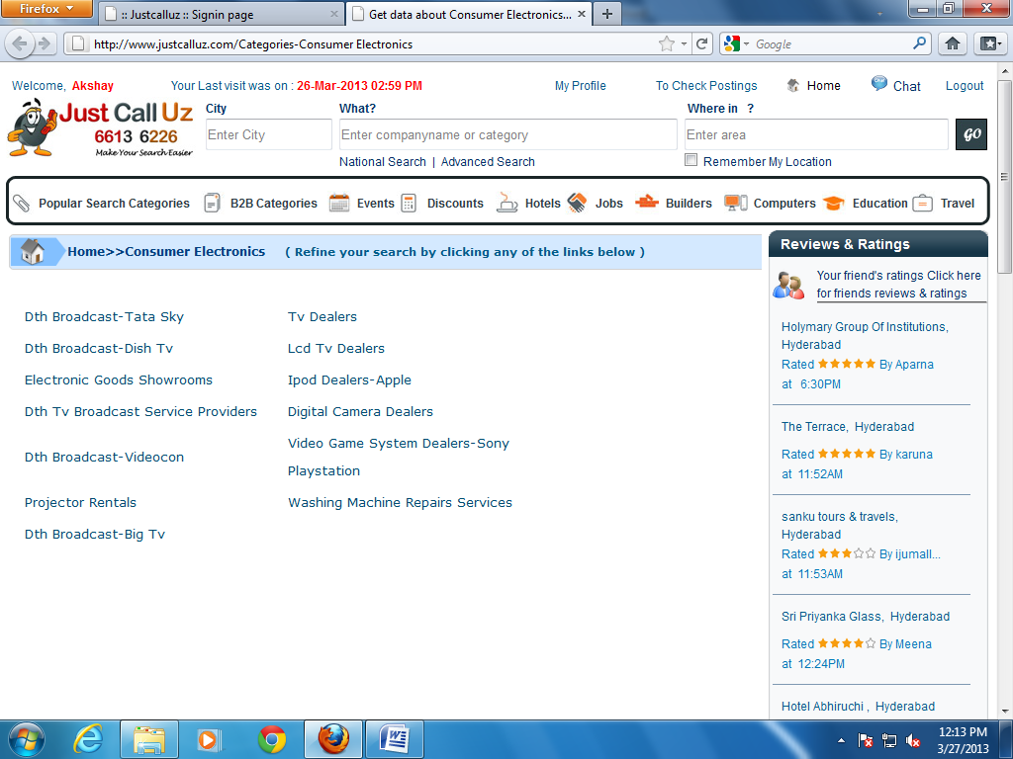

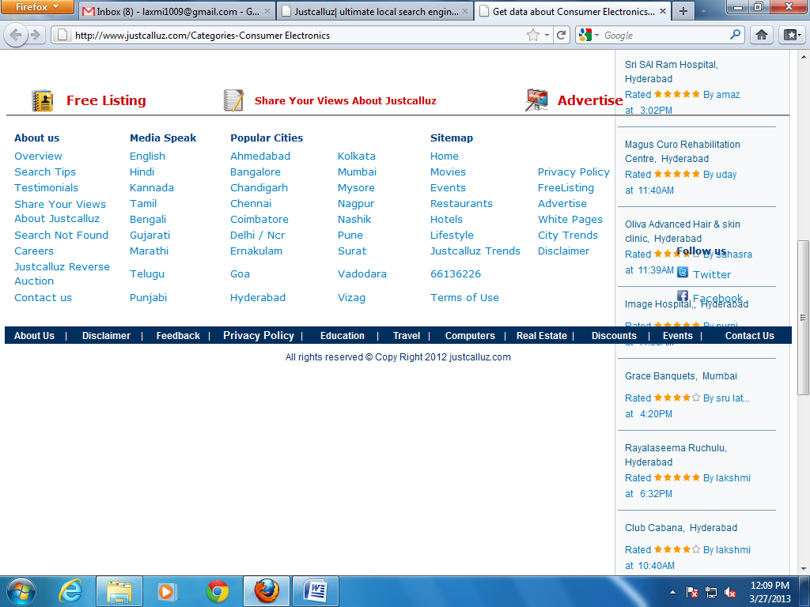

* Footer section is not working properly. It displays in the middle of the page when I clicked on categories.

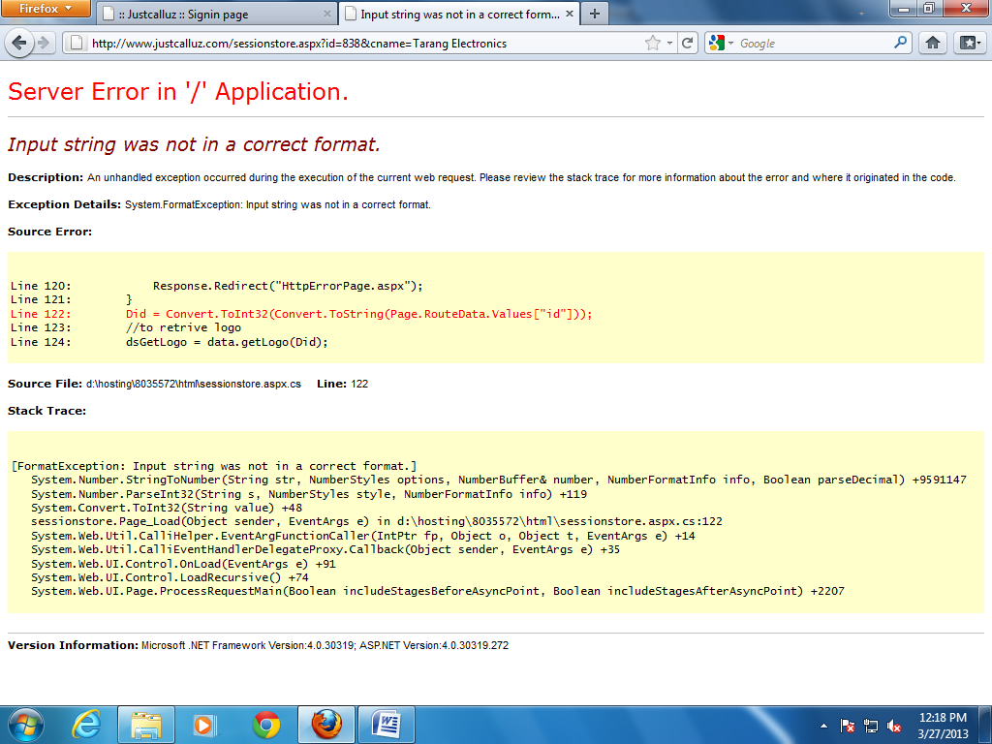

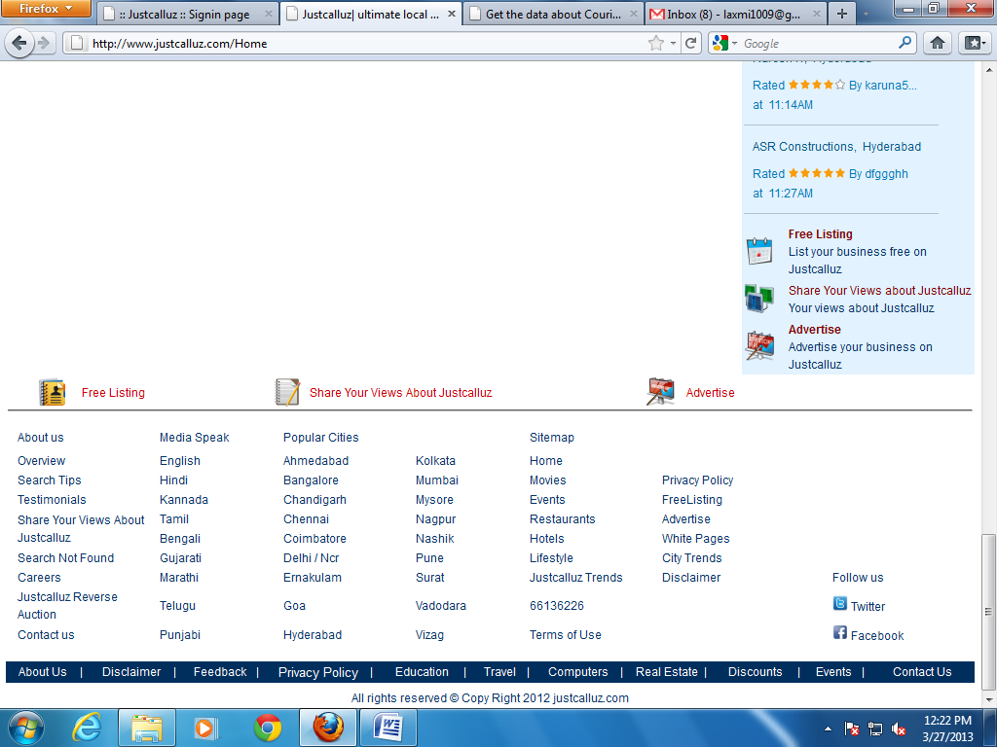

Remove the empty space here

(solved)

28-03-2013

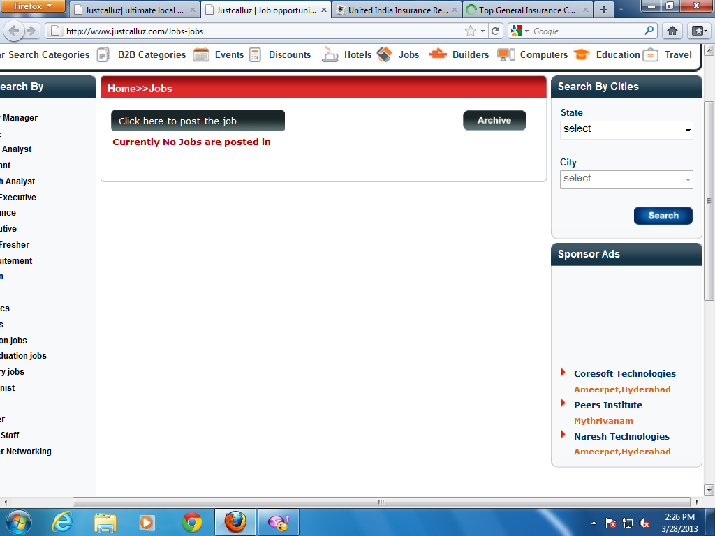

It displays empty space

(solved)

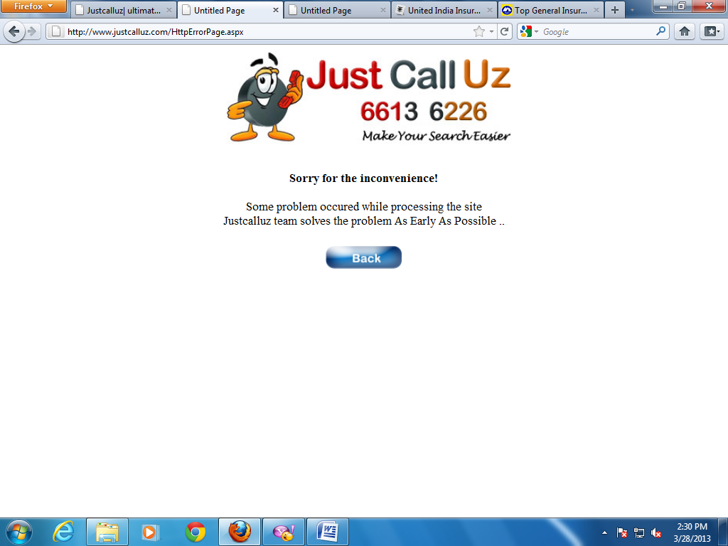

* Got an error when I clicked on search button on right side in jobs module.

(solved)

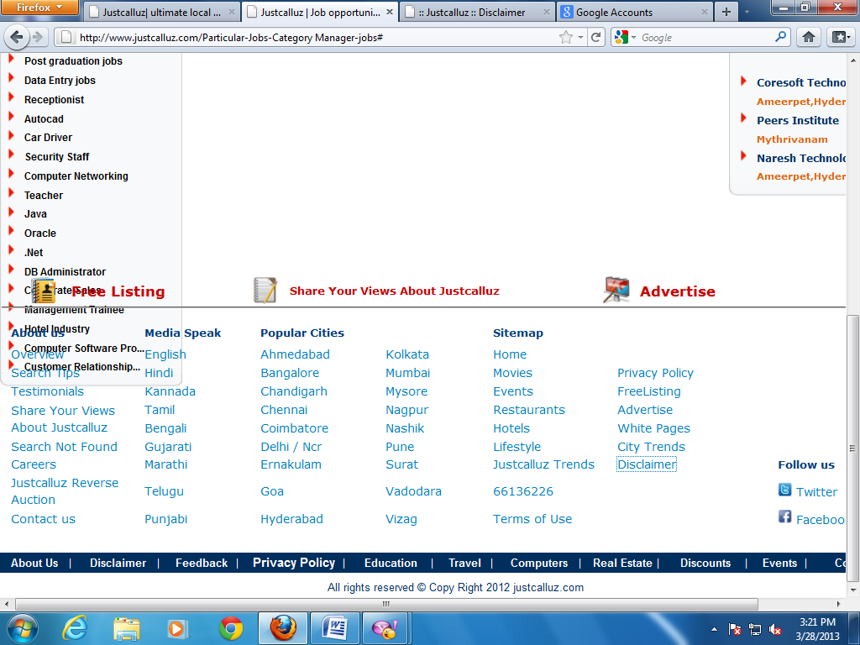

Justcalluz trends is not working

(solved)

29-03-2013

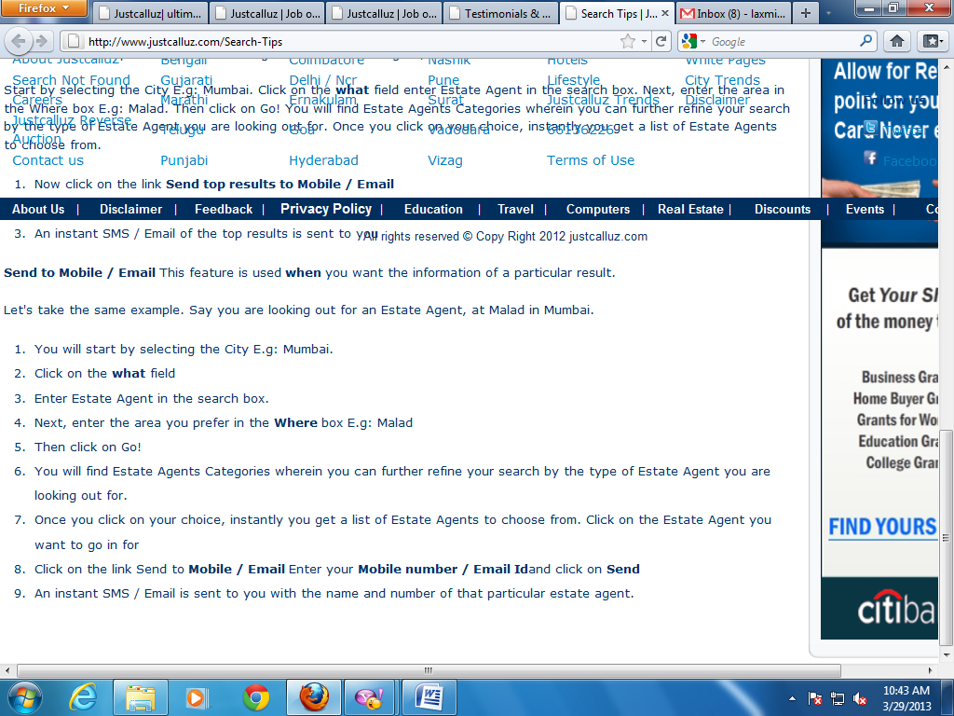

Put the space in between “where & in” and “email id & and”

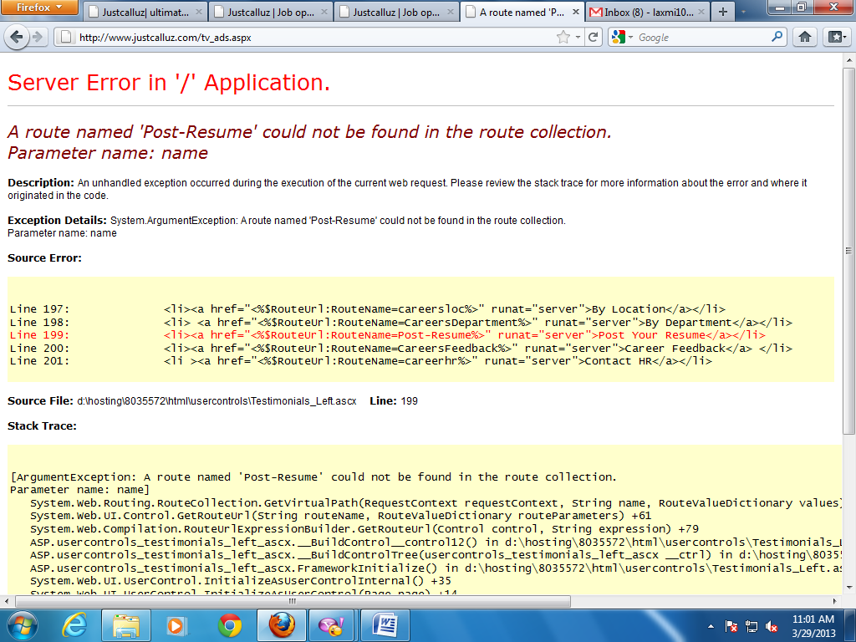

* Got an error when I clicked on Ads on left side in testimonials under footer section

(solved)

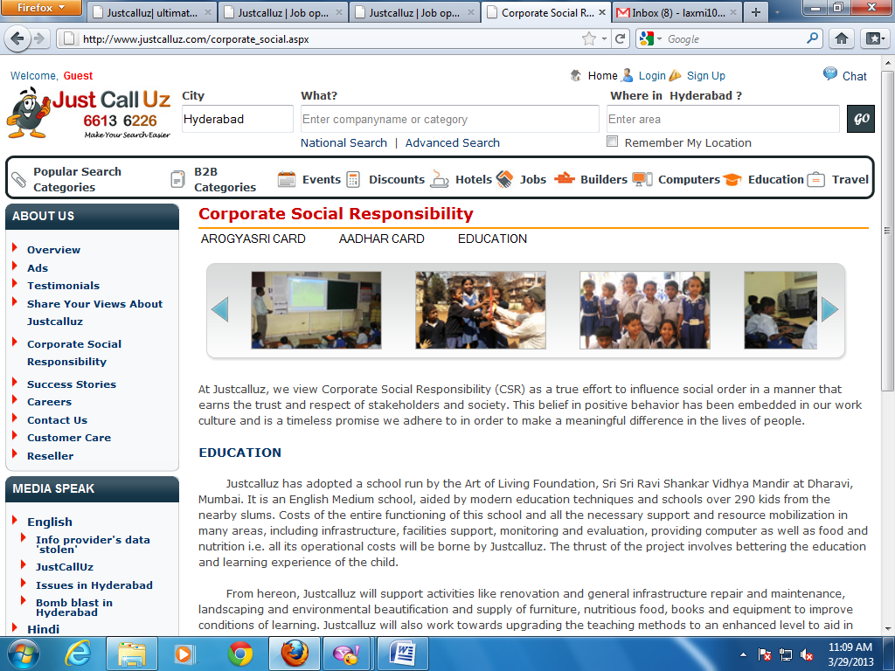

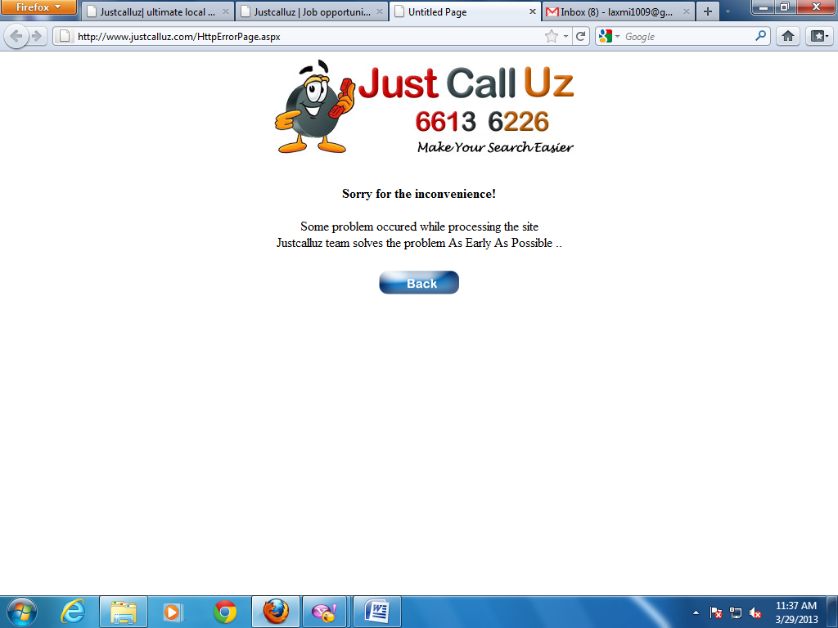

* Got an error when I clicked on “Search not found” in footer section.

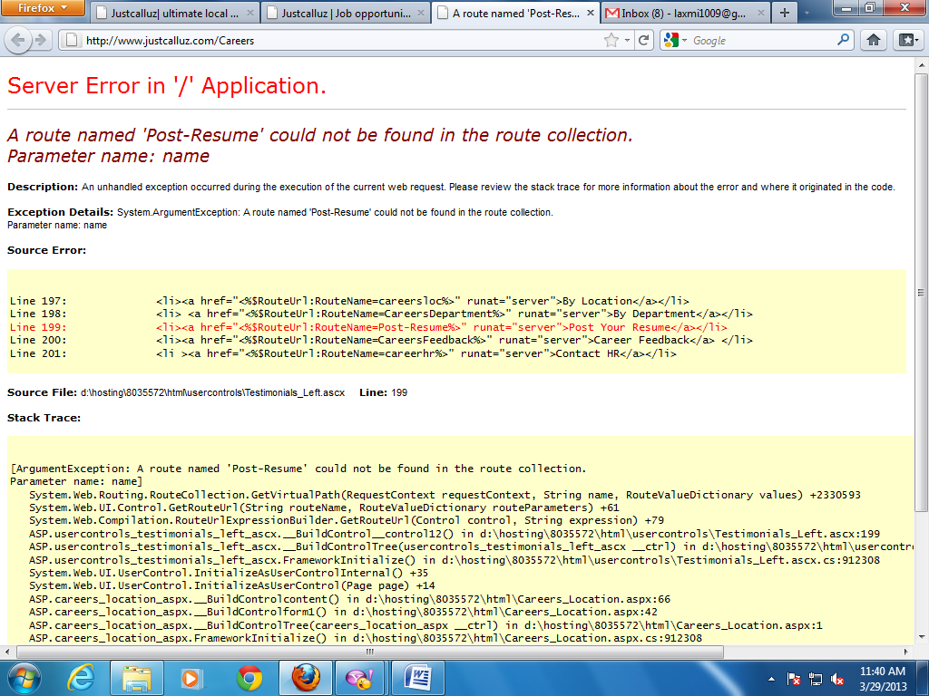

* Got an error when I clicked on “careers” in footer section.

(solved)

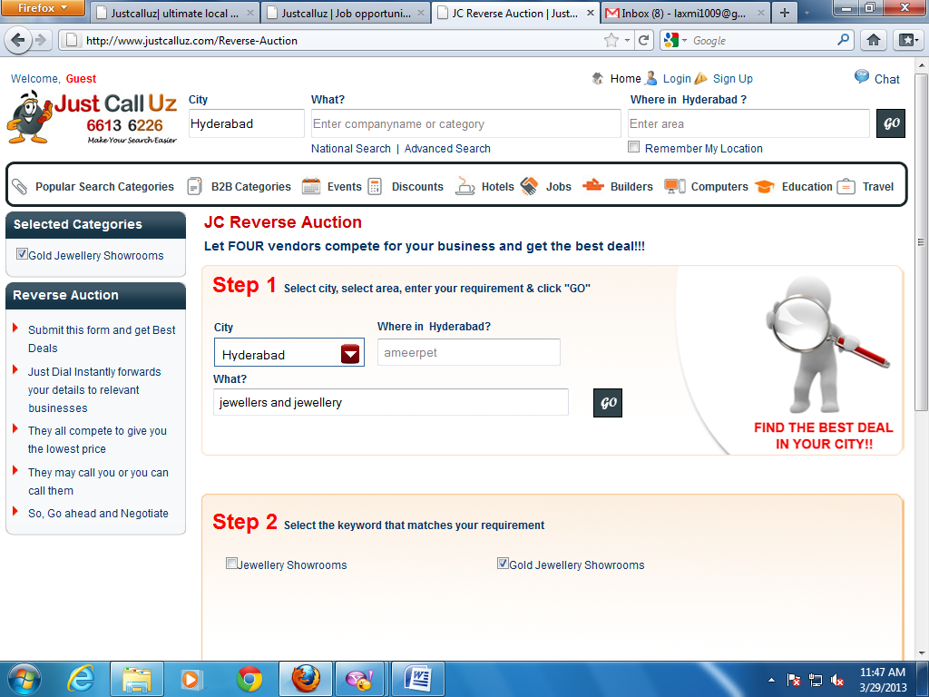

These links are not working

(not a error)

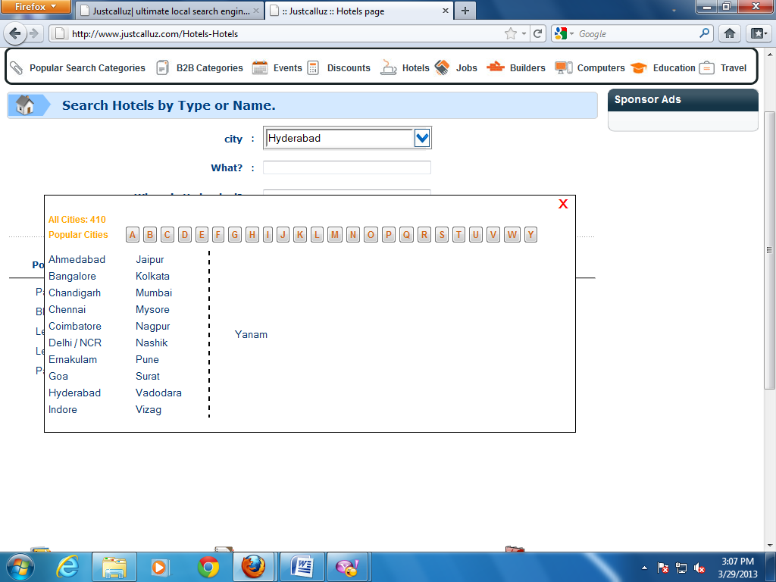

‘Z’ button is missing here

(not a error)

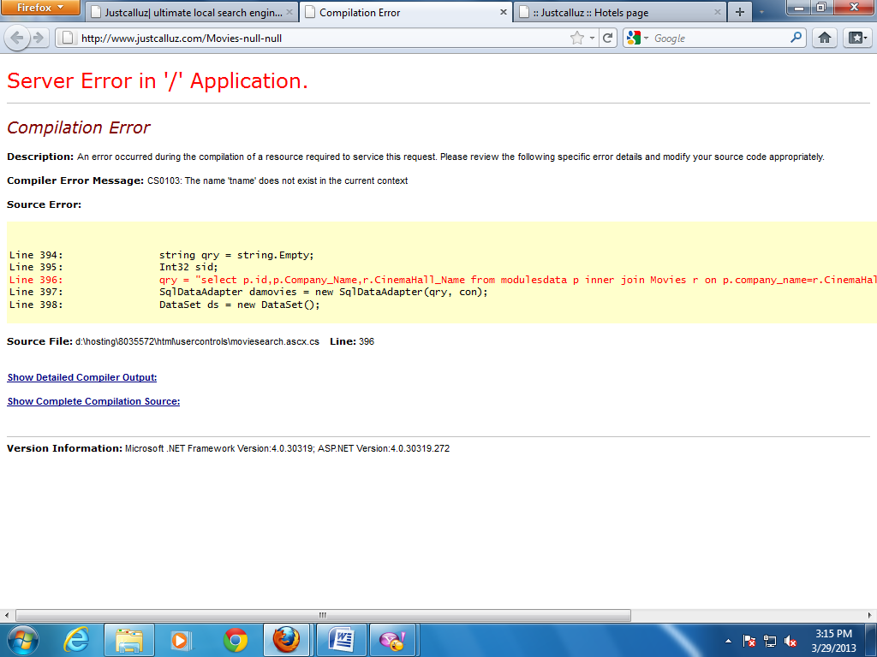

* Got an error when I clicked on movies in footer section.

(solved)

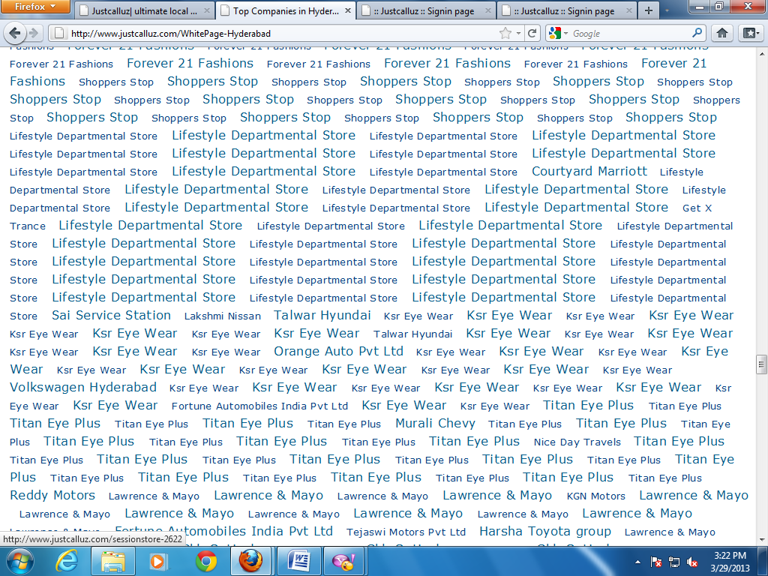

* Lifestyle departmental stores, ksr eye wear etc are repeated.

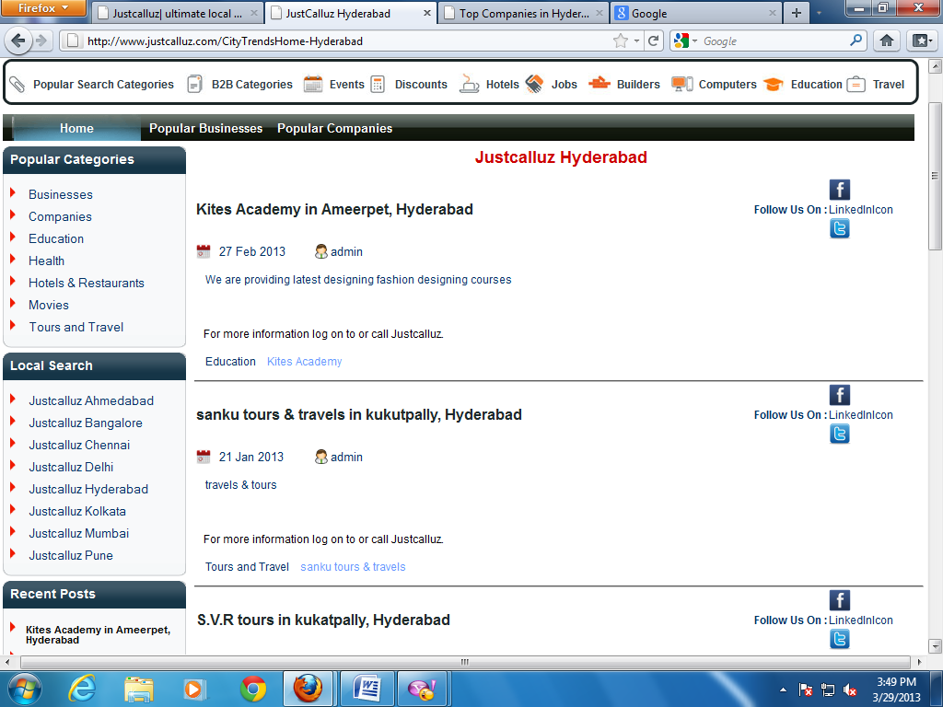

Got an error when I clicked on this links

Linkedin icon is not displaying

(working)